User Manual

of

CSAY OBSTACLE HEIGHT CALCULATION

*(Version 2023.1)*

*(A Free Open-Source Software)*

Based

On

OBSTACLE LIMITATION SURFACE

(ICAO ANNEX – 14 VOL – I, 9th EDITION)

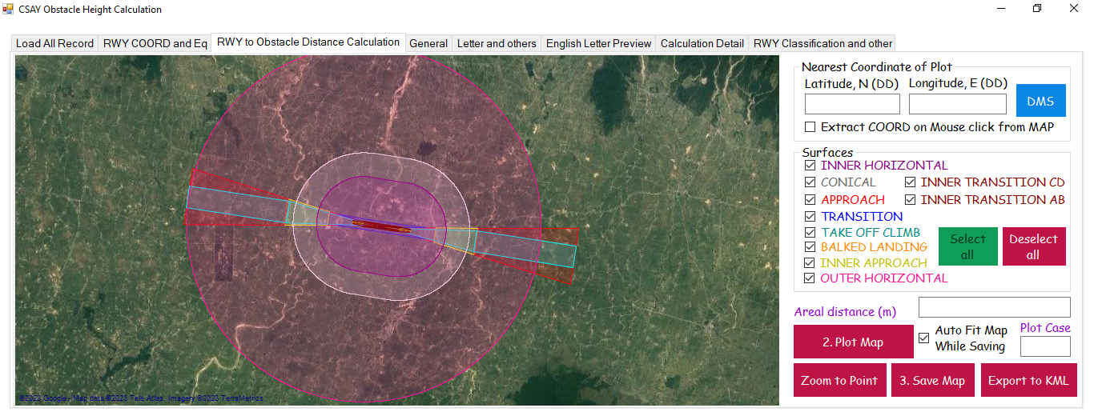

Er. AJAY YADAV

2023

Table of Content

LIST OF FIGURES 1

CHAPTER 1 DEFINITION 2

1.1 Definitions as per ICAO Annex 14 2

1.1.1 Aerodrome 2

1.1.2 Balked Landing 2

1.1.3 Aerodrome Reference point 2

1.1.4 Clearway 2

1.1.5 Displaced Threshold 2

1.1.6 Obstacle 2

1.1.7 Obstacle Free Zone (OFZ) 3

1.1.8 Obstacle Limitation Surface (OLS) 3

1.1.9 Runway 3

1.1.10 Runway strips 3

1.1.11 Threshold 3

CHAPTER 2 OBSTACLE LIMITATION SURFACE 4

2.1 Types of Obstacle Limitation Surfaces 4

2.2 OLS requirement 4

2.3 Details of each OLS 5

2.3.1 Conical Surface 5

2.3.2 Inner Horizontal Surface 6

2.3.3 Inner Approach Surface 7

2.3.4 Approach Surface 8

2.3.5 Transitional Surface 9

2.3.6 Inner Transitional Surface 9

2.3.7 Balked Landing Surface 11

2.3.8 Take Off Climb Surface 12

2.3.9 Outer Horizontal Surface 13

CHAPTER 3 INTRODUCTION TO SOFTWARE 14

3.1 Overview of Software 14

3.2 Functions of Software 14

3.3 Limitation of Software 14

3.4 Layout of Software 14

3.5 Input Text files (“*.txt”) and folder 15

3.6 Content of Tab 16

3.6.1 Load All Record 16

3.6.2 RWY COORD and Eq 16

3.6.3 RWY to Obstacle Distance Calculate 17

3.6.4 General 18

3.6.5 Letters and others 18

3.6.6 English Letter Preview 19

3.6.7 Calculation Detail 19

3.6.8 RWY Classification and other 20

3.6.9 Menu 21

3.6.10 Filter 22

3.7 Nomenclature of Runway corners 22

3.8 Output 23

3.8.1 Report 23

3.8.2 Letter in Nepali 24

3.8.3 Tippani in Nepali 25

3.8.4 Letter in English 26

3.9 Steps to calculate Obstacle Height with Auot-Process 27

# LIST OF FIGURES

Figure 1. Rwy, Strip and other detail 3

Figure 2. Conical Surface 5

Figure 3. Inner Horizontal Surface 6

Figure 4. Inner Approach Surface 7

Figure 5. Approach Surface 8

Figure 6. Transitional Surface 9

Figure 7. Inner Transitional Surface (AB Side) 10

Figure 8. Inner Transitional Surface (CD Side) 10

Figure 9. Balked Landing Surface 11

Figure 10. Take off Climb Surface 12

Figure 11. Outer Horizontal Surface 13

Figure 12. Input folder and its content 15

Figure 13. Load all Records Tab 16

Figure 14. RWY COORD and Eq Tab 16

Figure 15. RWY to Obstacle Distance Calculate Tab 17

Figure 16. DMS to DD Converter 17

Figure 17. General Tab 18

Figure 18. Letters and Others Tab 18

Figure 19. English Letter Preview Tab 19

Figure 20. Calculation Detail 19

Figure 21. RWY Classification and other Tab 20

Figure 22. AirportCode.txt file Format 20

Figure 23. Ellipsoid data for a Central Meridian 21

Figure 24. Menu Tab 21

Figure 25. About 21

Figure 26. Filter Tab 22

Figure 27. Runway corner nomenclature 22

Figure 28. Software Executable file Location 27

# DEFINITION

## Definitions as per ICAO Annex 14

### Aerodrome

A defined area on land or water (including any buildings, installations and equipment) intended to be used either wholly or in part for the arrival, departure and surface movement of aircraft.

### Balked Landing

A landing manoeuvre that is unexpectedly discontinued at any point below the obstacle clearance altitude/height (OCA/H).

### Aerodrome Reference point

The designated geographical location of an aerodrome

### Clearway

A defined rectangular area on the ground or water under the control of the appropriate authority, selected or prepared as a suitable area over which an aeroplane may make a portion of its initial climb to a specified height.

### Displaced Threshold

A threshold not located at the extremity of a runway

### Obstacle

All fixed (whether temporary or permanent) and mobile objects, or parts thereof, that:

a) are located on an area intended for the surface movement of aircraft; or

b) extend above a defined surface intended to protect aircraft in flight; or

c) stand outside those defined surfaces and that have been assessed as being a hazard to air navigation.

### Obstacle Free Zone (OFZ)

The airspace above the inner approach surface, inner transitional surfaces, and balked landing surface and that portion of the strip bounded by these surfaces, which is not penetrated by any fixed obstacle other than a low-mass and frangibly mounted one required for air navigation purposes.

### Obstacle Limitation Surface (OLS)

It defines the limit to which objects may project into the airspace

### Runway

A defined rectangular area on a land aerodrome prepared for the landing and take-off of aircraft.

### Runway strips

A defined area including the runway and stopway, if provided, intended:

a) to reduce the risk of damage to aircraft running off a runway; and

b) to protect aircraft flying over it during take-off or landing operations.

### Threshold

The beginning of that portion of the runway usable for landing.

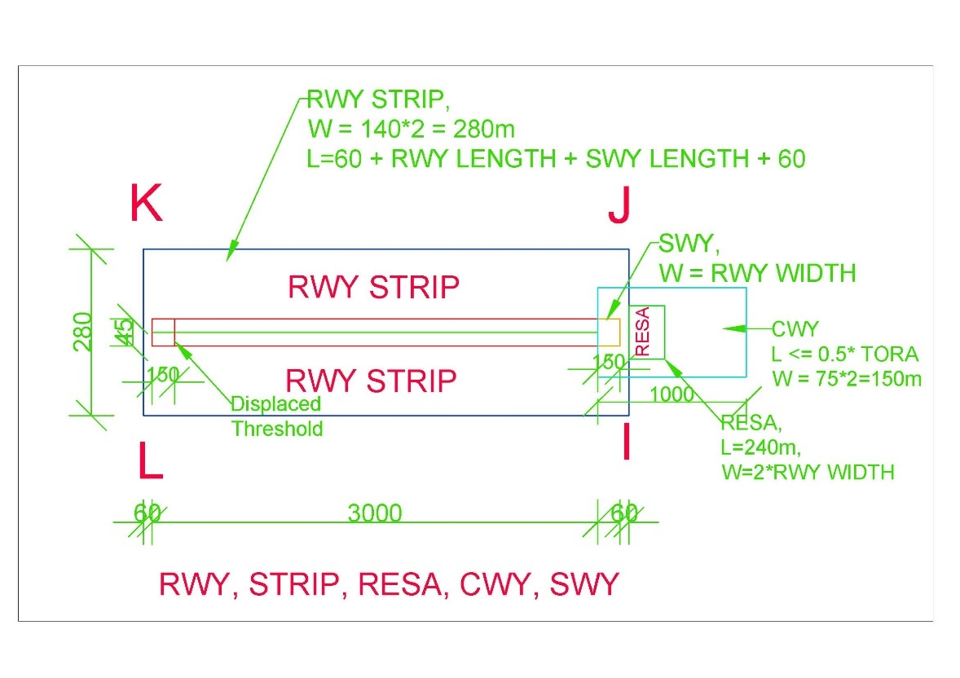

Figure 1. Rwy, Strip and other detail

# OBSTACLE LIMITATION SURFACE

## Types of Obstacle Limitation Surfaces

1. CONICAL SURFACE
2. INNER HORIZONTAL SURFACE
3. INNER APPROACH SURFACE
4. APPROACH SURFACE
5. TRANSITIONAL SURFACE
6. INNER TRANSITIONAL SURFACE
7. BALKED LANDING SURFACE
8. TAKEOFF CLIMB SURFACE
9. OUTER HORIZONTAL SURFACE

## OLS requirement

|  |  |  |
| --- | --- | --- |
| Runway Category | Runway Sub-Category | Obstacle Limitation surface |
| Non-Instrument Runway |  | 1. Conical surface 2. Inner Horizontal 3. Approach surface 4. Transitional surface |
| Instrument Runway | Non-Precision Approach Runway | 1. Conical surface 2. Inner Horizontal 3. Approach surface 4. Transitional surface |
| Precision Approach Runway Category I | Mandatory Surfaces (Shall be)   1. Conical surface 2. Inner Horizontal 3. Approach surface 4. Transitional surface   *Optional Surfaces (Should be)*   1. *Inner Approach surface* 2. *Inner Transitional surface* 3. *Balked landing surface* |
| Precision Approach Runway Category II or III | 1. Conical surface 2. Inner Horizontal 3. Approach surface 4. Transitional surface 5. Inner Approach surface 6. Inner Transitional surface 7. Balked landing surface |

* Note – 1: Take off climb surface shall be established for all runways meant of Take off climb.

## Details of each OLS

In this document, calculations and drawings shall be based on “**PRECISION APPROACH RUNWAY CAT II OR III**” based on Table 4-1 Dimensions and slopes of obstacle limitation surfaces — Approach runways of ICAO ANNEX – 14, Vol – I, 9th Edition.

### Conical Surface

|  |  |
| --- | --- |
| Surfaces | Dimension |
| CONICAL |  |
| Slope_% | 5 |
| Height_m | 100 |

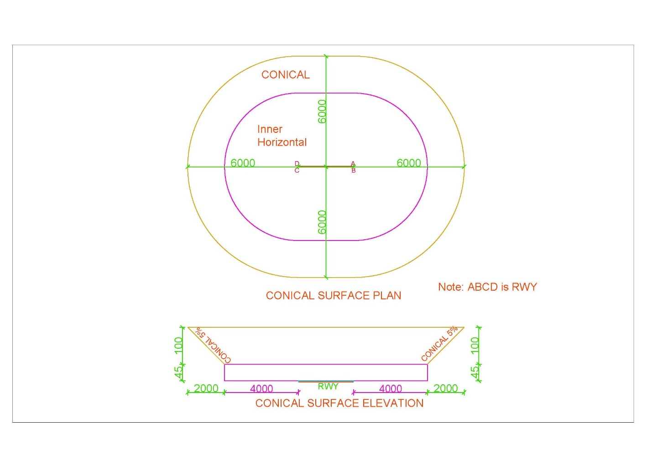

Figure 2. Conical Surface

### Inner Horizontal Surface

|  |  |
| --- | --- |
| Surfaces | Dimension |
| INNER_HORIZONTAL |  |
| Height_m | 45 |
| Radius_m | 4000 |

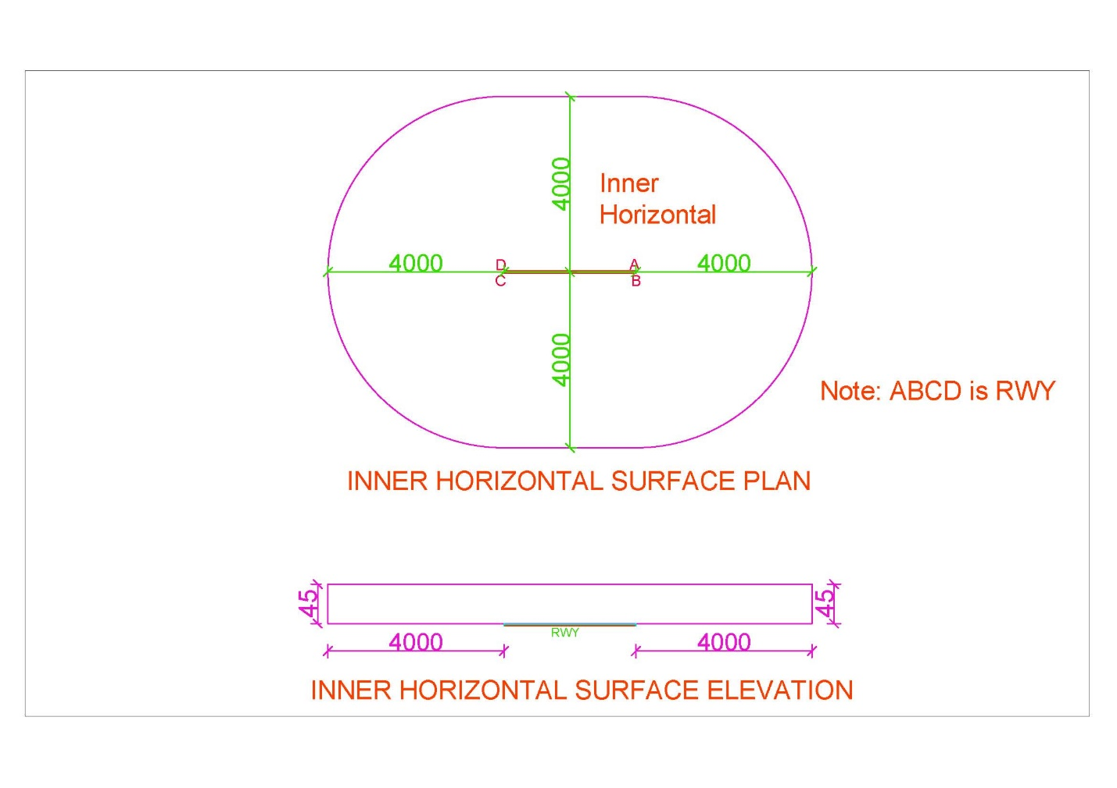

Figure 3. Inner Horizontal Surface

### Inner Approach Surface

|  |  |
| --- | --- |
| Surfaces | Dimension |
| INNER_APPROACH |  |
| Width_m | 120 |
| Distance_from_threshold_m | 60 |
| Length_m | 900 |
| Slope_% | 2 |

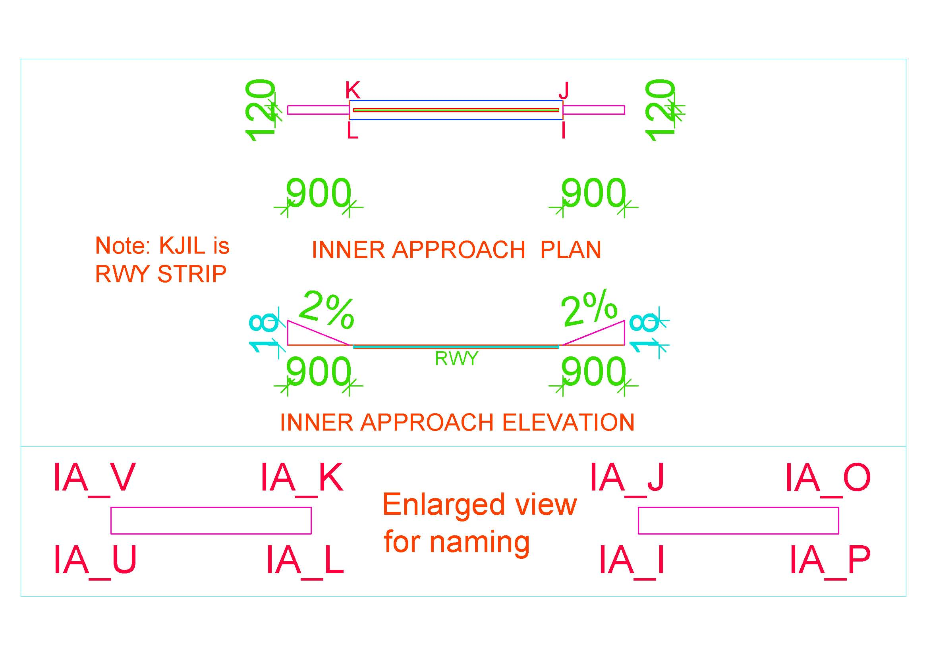

Figure 4. Inner Approach Surface

### Approach Surface

|  |  |  |  |
| --- | --- | --- | --- |
| Surfaces | Dimension | Surfaces | Dimension |
| Length_of_inner_edge_m | 280 | Second_Section |  |
| Distance_from_threshold_m | 60 | Length_m | 3600 |
| Divergence_% | 15 | Slope_% | 2.5 |
| First_Section |  | Horizontal_Section |  |
| Length_m | 3000 | Length_m | 8400 |
| Slope_% | 2 |  |  |

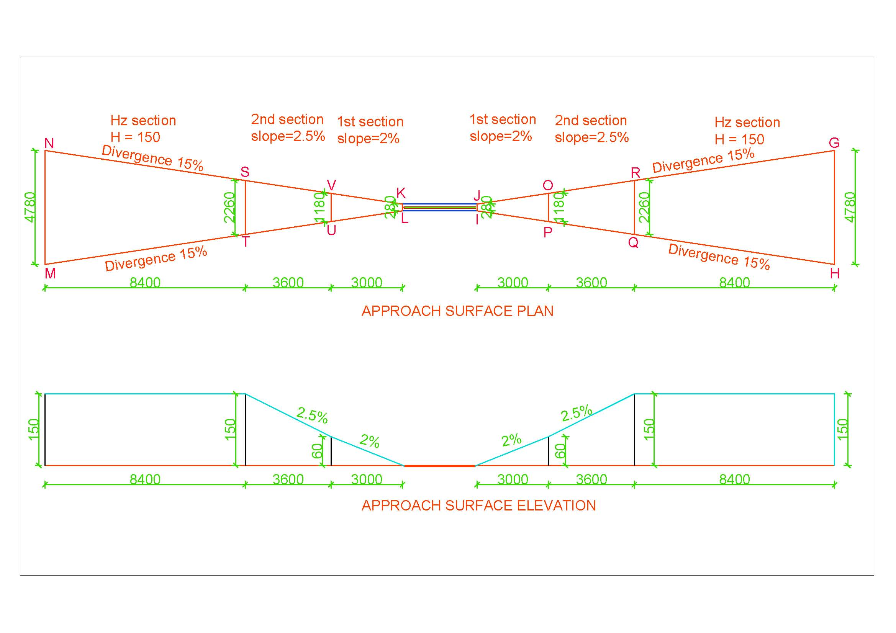

Figure 5. Approach Surface

### Transitional Surface

|  |  |
| --- | --- |
| Surfaces | Dimension |
| INNER_TRANSITIONAL |  |
| Slope_% | 14.3 |

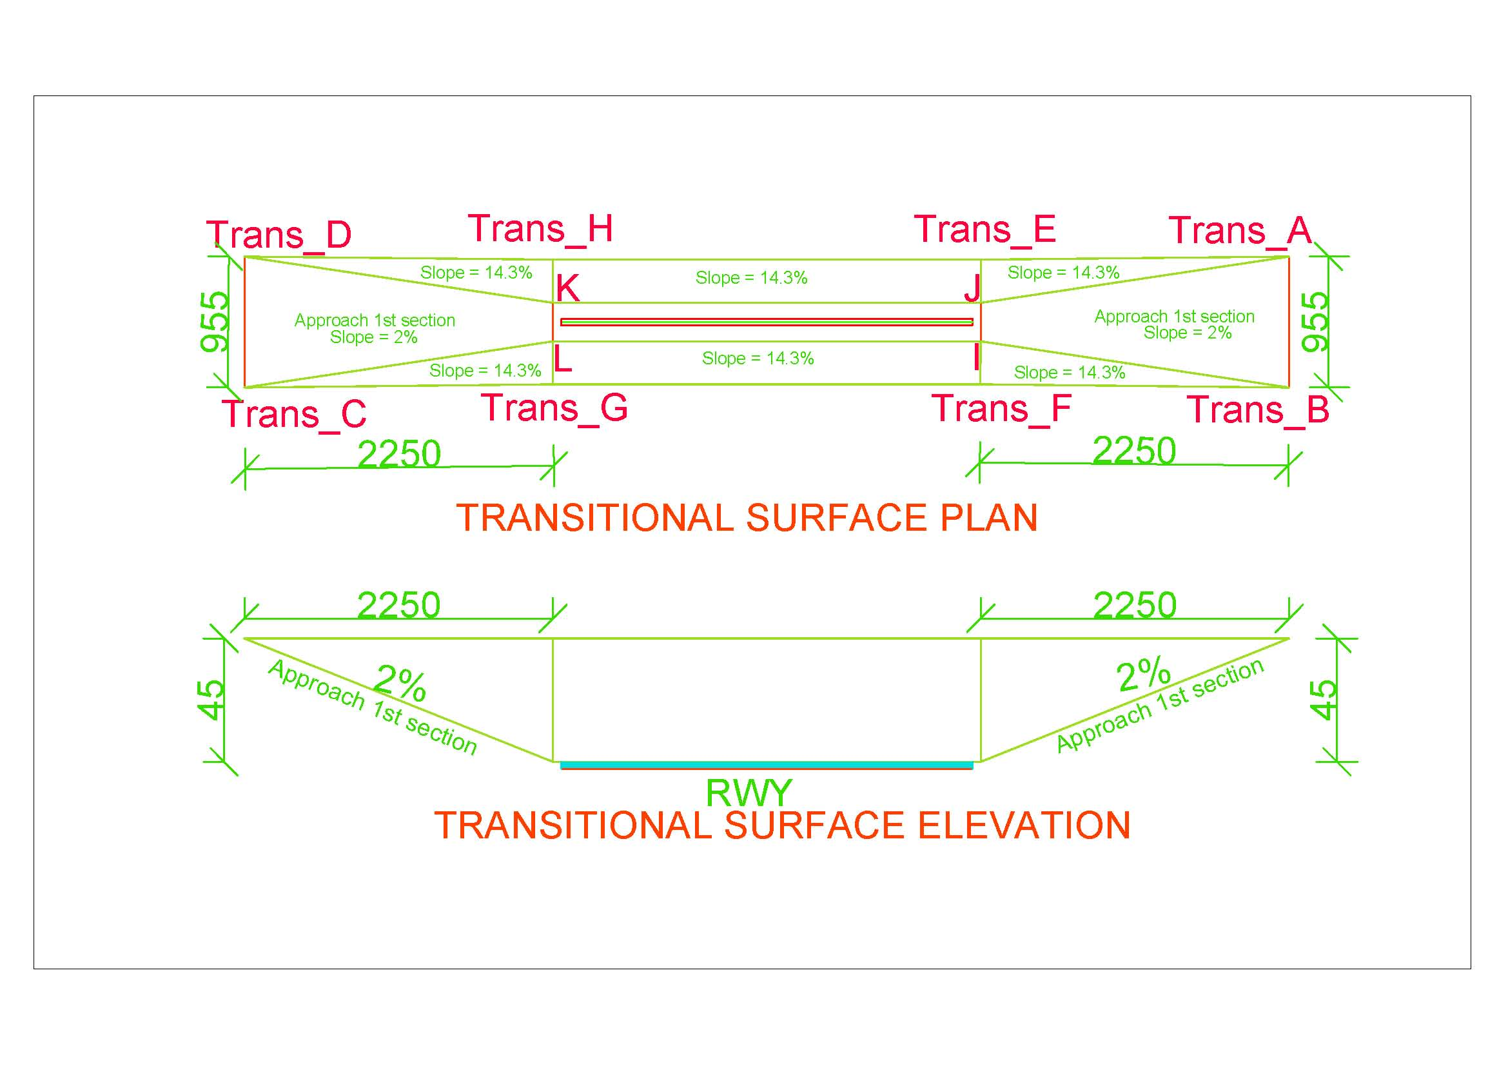

Figure 6. Transitional Surface

### Inner Transitional Surface

|  |  |
| --- | --- |
| Surfaces | Dimension |
| TRANSITIONAL |  |
| Slope_% | 33.3 |

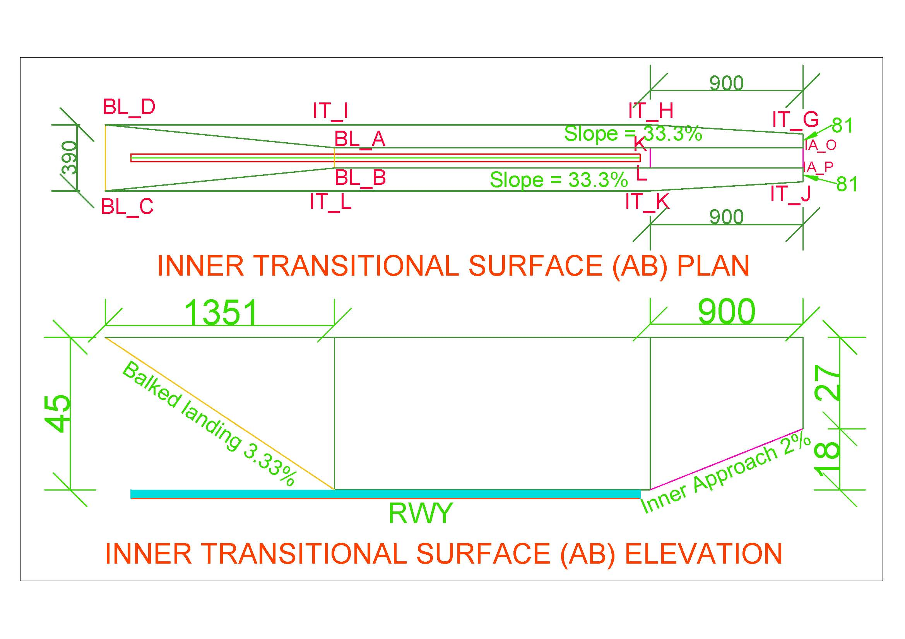

Figure 7. Inner Transitional Surface (AB Side)

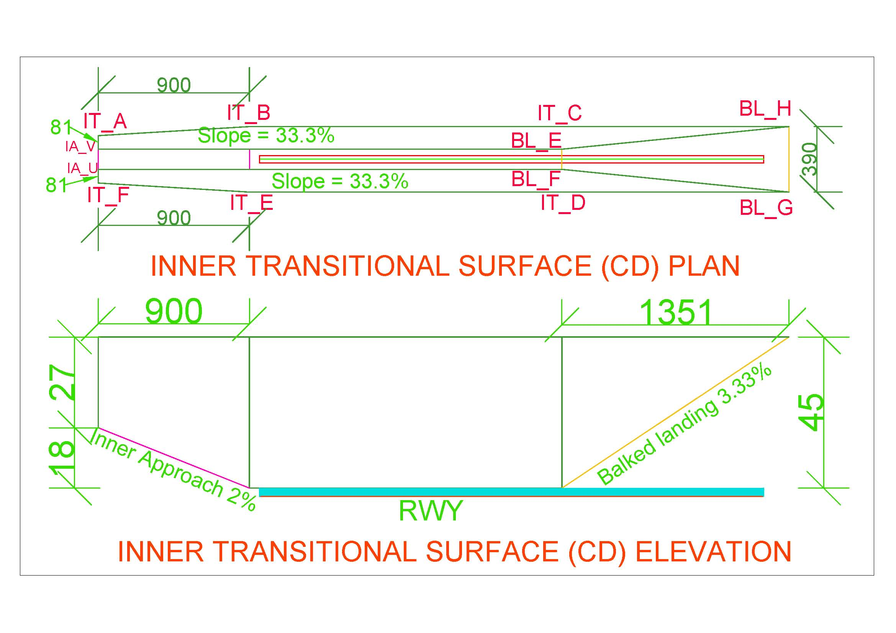

Figure 8. Inner Transitional Surface (CD Side)

### Balked Landing Surface

|  |  |
| --- | --- |
| Surfaces | Dimension |
| BALKED_LANDING |  |
| Length_of_inner_edge_m | 120 |
| Distance_from_threshold_m | 1800 |
| Divergence_% | 10 |
| Slope_% | 3.33 |

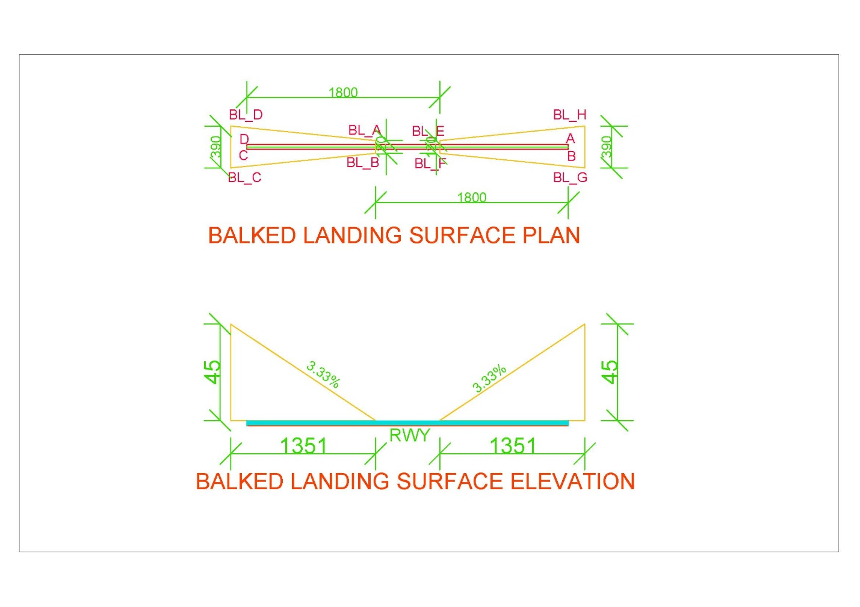

Figure 9. Balked Landing Surface

* *Note:* 
  + *If threshold is displaced by distance ‘d’, Balked landing surface will also be displaced by distance ‘d’ in the direction of displaced threshold.*
  + *In* Figure 22*, AB_Threshold_displaced_By and CD_Threshold_displaced_By shall be given value d1 and d2 respectively if Threshold AB is displaced by d1 and CD is displaced by d2.*
  + *If thresholds aren’t displaced, value will be zero*

### Take Off Climb Surface

|  |  |
| --- | --- |
| Surfaces | Dimension |
| TAKE_OF_CLIMB_SURFACE |  |
| Length_of_inner_edge_m | 180 |
| Distance_from_RWY_End_m | 60 |
| Divergence_% | 12.5 |
| Final_Width_m | 1800 |
| Length_m | 15000 |
| Slope_% | 2 |

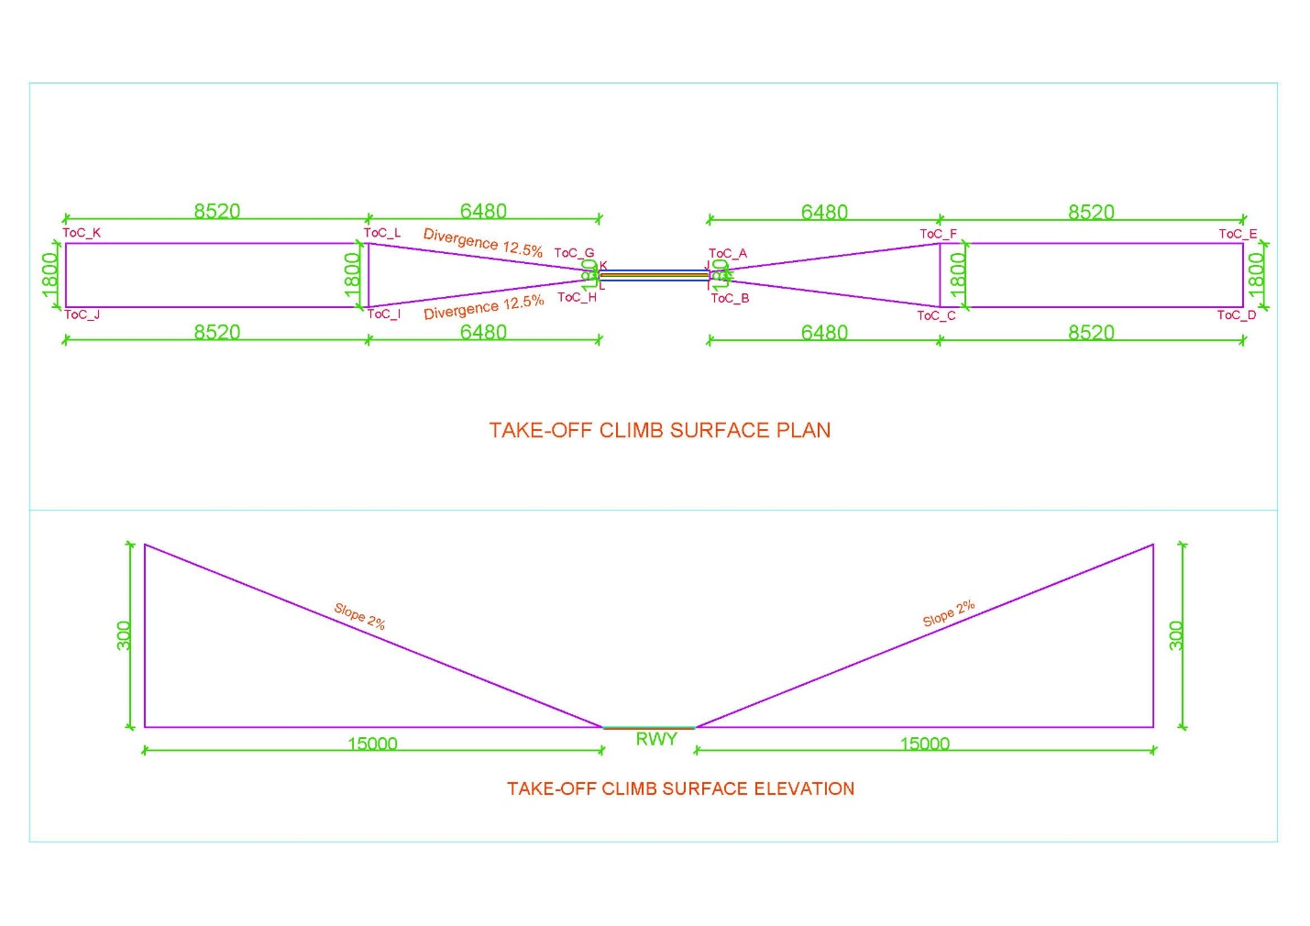

Figure 10. Take off Climb Surface

* *Note:* 
  + *Take-Off Climb Surface starts from 60m end of runway (i.e. RWY strip) or end of clearway, whichever is greater.*
  + *For example, as in* Figure 1*,*
    - *Distance of strip from RWY end (d1) = SWY + strip end = 150+60=210m*
    - *Distance of CWY from RWY end (d2) = 1000 m*
    - *Distance beyond strip end of CWY = 1000-210=790 m = d*
    - *This value i.e., ‘d’ is to be placed for respective end of runway in AB_CLWY_beyond_strip and CD_CLWY_beyond_strip as in* Figure 22*.*

### Outer Horizontal Surface

|  |  |
| --- | --- |
| Surfaces | Dimension |
| Center at | ARP |
| Radius_m | 15000 |

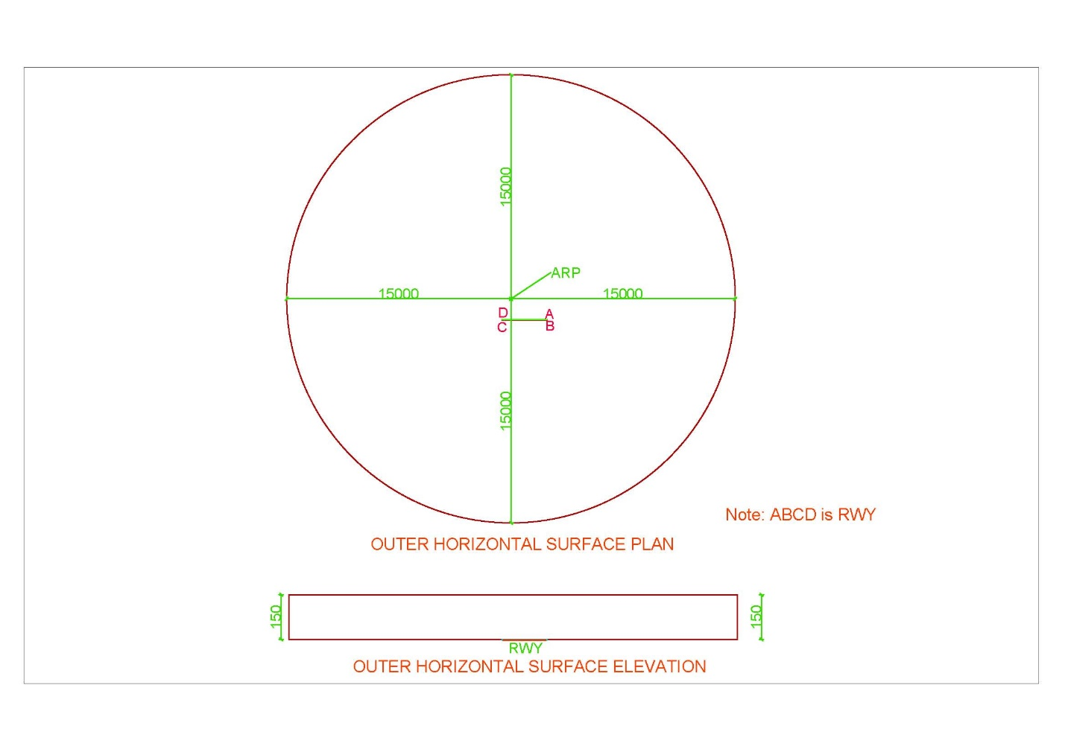

Figure 11. Outer Horizontal Surface

# INTRODUCTION TO SOFTWARE

## Overview of Software

|  |  |
| --- | --- |
| Name of the Software | **CSAY Obstacle Height Calculation** |
| Version | 2023.1 |
| Type | Free and Open source |
| Operating System | Windows 10 (preferable) or higher |
| Display resolution of Monitor screen (Recommended) | 1366 x 768 |
| Setup | No installation required |
| Link to download | <https://github.com/ajayyadavay/CSAYObstacleHeightCalculation> |
| Created/Developed/Programmed by | Er. Ajay Yadav |
| E-mail: | [Civil.ajayyadav@gmail.com](mailto:Civil.ajayyadav@gmail.com) |

## Functions of Software

1. Finds the height of the obstacle
2. Generates OLS for any runway orientation of any country with correct input of Projection system of coordinate
3. Creates pdf of the report
4. Draws map of Obstacle Limitation surface and plotted point showing distance between runway and obstacle location
5. Creates tippani in Nepali and Letter in Nepali as well as English
6. Exports the route between runway and obstacle and their points to KML file
7. Allows user to Perform database operations: ADD, MODIFY, DELETE, DISPLAY, FILTER
8. Exports the saved/added data to excel
9. Allows user to Auto process which will generate report, tippani, letter, KML and Map saved in a folder
10. Allows user to enter decimal degrees (DD) of location of obstacle and also assists in converting from Degree, Minute and Second (DMS) format to DD.
11. Allows user to draw all the obstacle limitation surfaces or only selected surfaces
12. Allows user to extract coordinate (latitude and longitude) from map on mouse click

## Limitation of Software

1. This software can be used for only one Runway and not for the parallel or intersecting runways
2. The inner transition surfaces use only one Reduced Level of Runway and not the nearest runway centerline Reduced Level. However, it will not affect the levelled runway.

## Layout of Software

1. There are Eight Tabs
2. All the Text boxes labelled with black foreground is input and others are either calculated textboxes or loaded from the ‘*.txt’ files
3. For Auto process, input all required value and click “Auto Process” button
4. Textboxes with orange colored label in “General” tab are compulsory input
5. All the Combo Boxes have their values loaded from “*.txt” files
6. Map is drawn in “RWY to obstacle distance calculation” tab
7. At bottom, there is “Menu” tab and “Filter” Tab.

## Input Text files (“*.txt”) and folder

All the text files contain data as per the name of the text files.

*Note: The user is allowed to only edit the content of text files strictly adhering to the format and user cannot rename or delete the text files or change the location of the text files.*

Figure 12 shows folders and its content. The user can edit content as per their requirement.

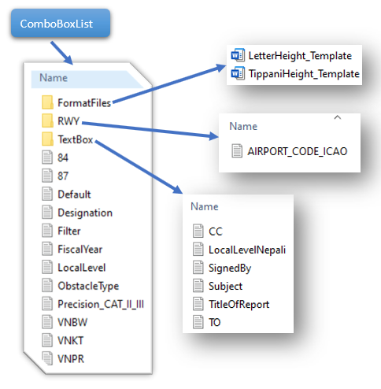

Figure 12. Input folder and its content

## Content of Tab

### Load All Record

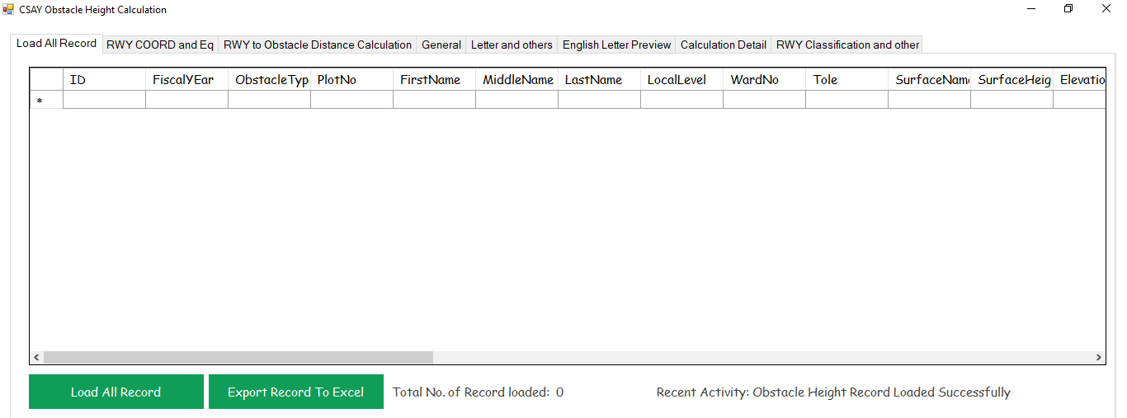

Figure 13. Load all Records Tab

### RWY COORD and Eq

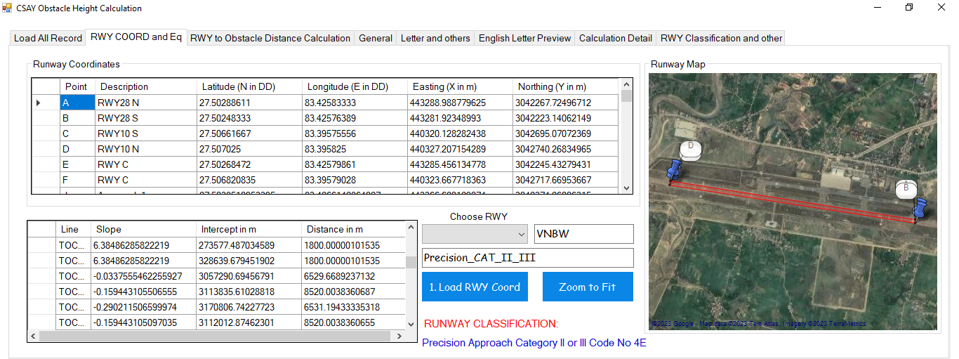

Figure 14. RWY COORD and Eq Tab

1. As in Figure 14, First enter the required data in specified format in text files as in Figure 12
2. Choose RWY
3. A text file of the same name (Here, it is VNBW) should be present in folder as in Figure 12
4. Click button “1. Load RWY Coord” and “Zoom to Fit” to fit.
5. As in Figure 12, the “default.txt” contains name of the Airport code which will be automatically loaded, if file exists, when the software opens.

### RWY to Obstacle Distance Calculate



Figure 15. RWY to Obstacle Distance Calculate Tab

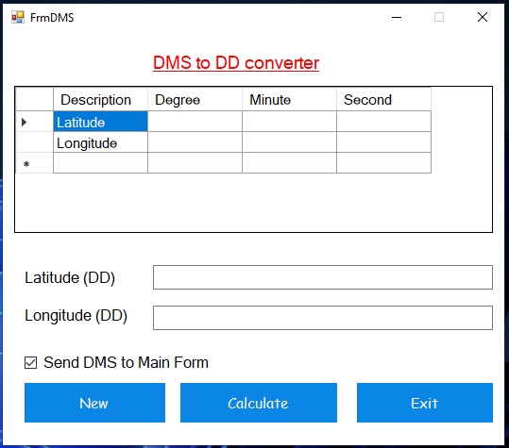

Figure 16. DMS to DD Converter

1. Input latitude and longitude in DD format.
2. Click DMS and enter latitude and longitude in DMS format as in Figure 16.
3. If “Extract COORD on mouse click from Map” is checked on, latitude and longitude text boxes will be filled the latitude and longitude of the map and if checked off, user has to input the coordinate themselves.
4. Under surfaces, select the required surfaces to display
5. Click button “2. Plot Map” to plot the obstacle and runway point and calculate areal distance
6. If “Auto Fit Map While Saving” is checked on, the map will be autofit to the points plotted and that map will be saved but if it is checked off, the user can adjust the map to desired zoom level by scrolling mouse wheel and then click “3. Save Map”
7. Click “Export to KML” to export the points of runway, obstacle and line joining them to KML file
8. “Zoom to Point” zooms map to the plotted point

### General

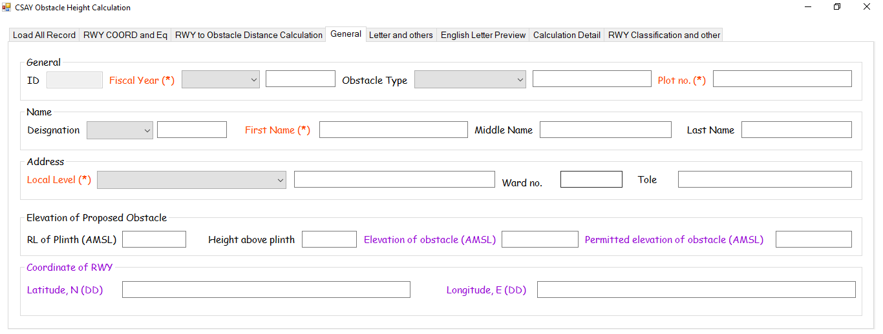

Figure 17. General Tab

1. All orange label marked with (*) are mandatory fields/textboxes
2. All black labelled fields are to be entered by user
3. Other are calculated or loaded from text files

### Letters and others

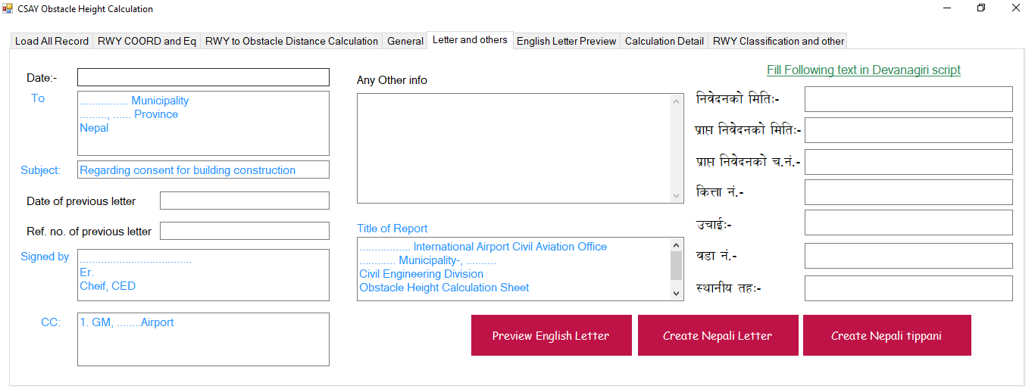

Figure 18. Letters and Others Tab

1. All black labeled are input
2. Blue colored fields are loaded form text files as shown in Figure 12.
3. No need to write in Devanagari script i.e., Nepali because when you input in English, these Devanagari fields will be automatically filled
4. “Preview English Letter” button will open “English Letter Preview” Tab as shown in
5. “Create Nepali Letter” and “Create Nepali Tippani” button will create letter and Tippani in the format contained in “FormatFiles” folder as shown in Figure 12.

### English Letter Preview

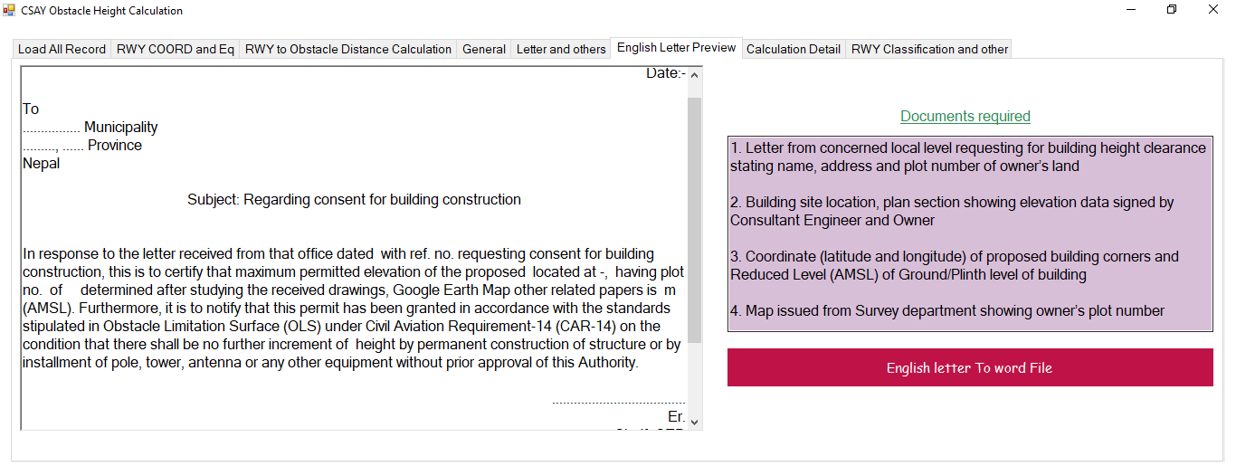

Figure 19. English Letter Preview Tab

1. English letter will appear in the white text box on the left-hand side
2. Date, designation, obstacle elevation etc. will be automatically filled after calculation and you have input all the required data
3. “English letter To Word File” will export the content of the text box in word file so that you can edit if necessary

### Calculation Detail

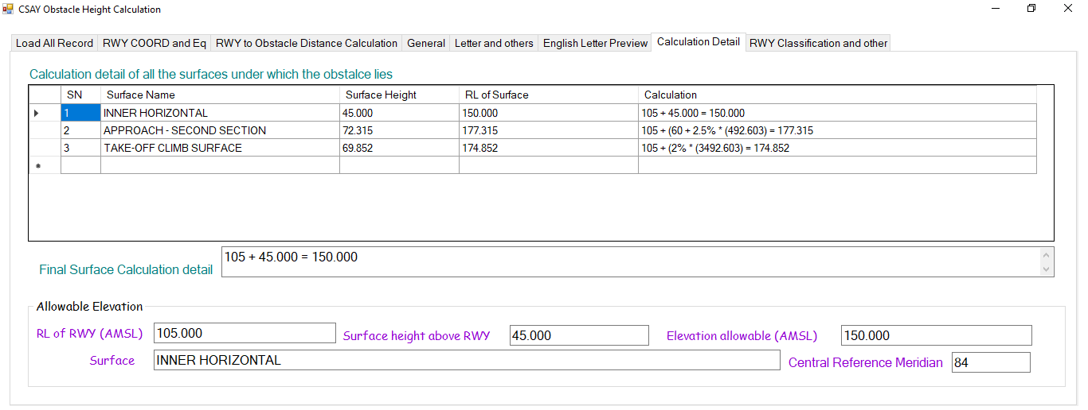

Figure 20. Calculation Detail

1. All the OLS below which the obstacle lies, will be listed with detailed calculation in the table as shown in Figure 20.
2. The minimum elevation data and corresponding surfaces will be shown in the text boxes and that shall be added to the table as shown in Figure 13.

### RWY Classification and other

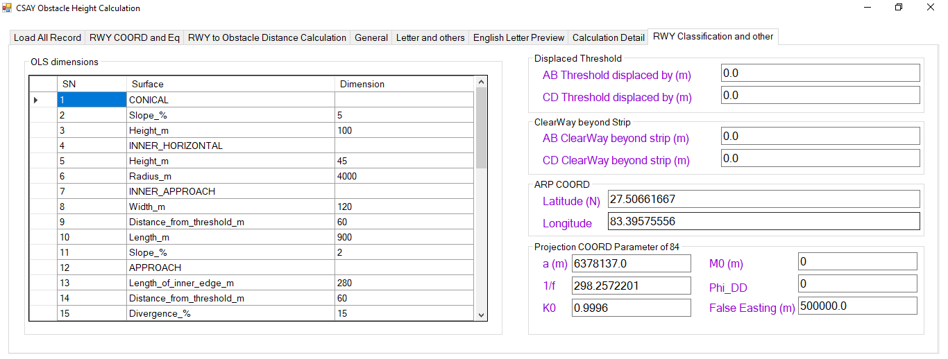

Figure 21. RWY Classification and other Tab

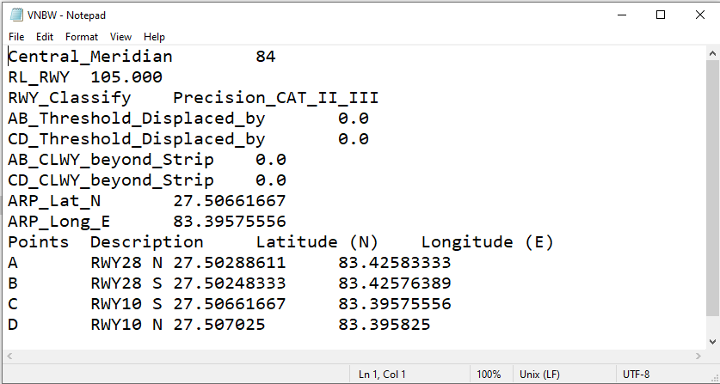

Figure 22. AirportCode.txt file Format

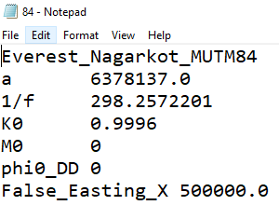

Figure 23. Ellipsoid data for a Central Meridian

1. “OLS dimensions” table contains data of file “Precision_CAT_II_III.txt” as shown in Figure 12.
2. The name of the file containing data for “OLS dimension” table of Figure 21, should be same as that of RWY_Classify as in Figure 22, i.e., “Precision_CAT_II_III.txt”.
3. “Displaced Threshold”, “Clearway beyond Strip”, “ARP COORD” shall be contained in file of {AirportCodeName.txt}; Here “VNBW.txt” as shown in Figure 22.
4. “Project COORD Parameter” contains data of projection system of different ellipsoid. As shown in Figure 22, Central Meridian is 84 so there should be a text file “84.txt” containing data of projection system as shown in Figure 12 and Figure 23.

### Menu

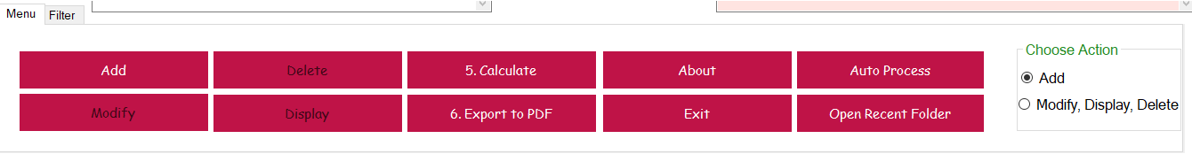

Figure 24. Menu Tab

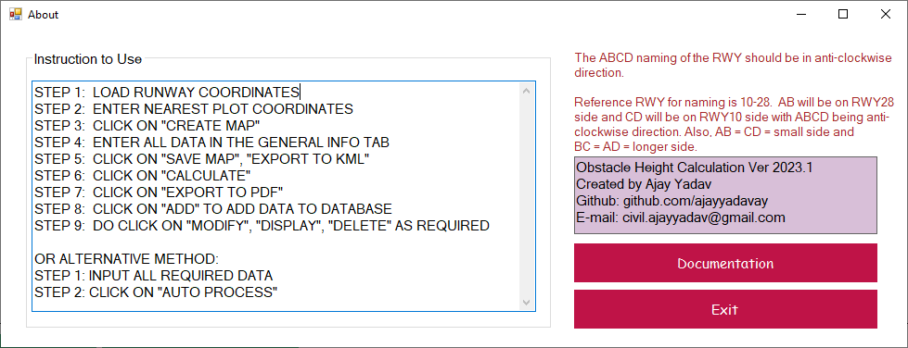

Figure 25. About

1. If chosen action is, Radio “Add” then button “Add” will be enabled and user will be allowed to add data and if chosen action is Radio “Modify, Display, Delete”, then button “Delete”, “Modify” and “Display” will be enabled and button “Add” will be disabled.
2. To Display, Modify and Delete, go to “General” Tab and enter ID
3. The ID can be known by clicking on button “Load All Record” of Figure 13
4. When the user click on “Add” button, all data are added to database and ID auto-increases.
5. Button “6. Export to PDF” will export the report to PDF.
6. All the projects are saved in Folder “ObstacleProjectFolders”.

### Filter

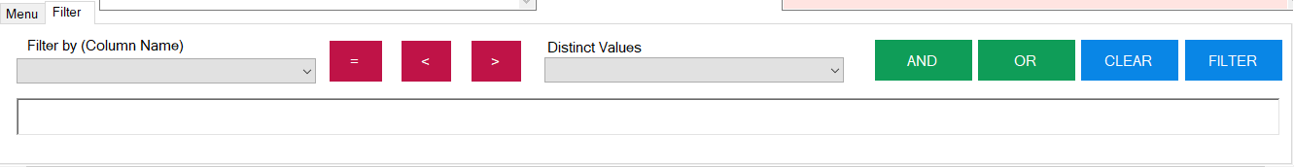

Figure 26. Filter Tab

1. Format of Filter is –
   1. ‘FirstName’=’Alpha’ OR ‘LastName’=’Yankee’
   2. Those records will be shown in the table of Figure 13 having First name as ‘Alpha’ or Last Name as ‘Yankee’

## Nomenclature of Runway corners

1. The naming of corners of Runway corners shall be according to Figure 27.
2. Reference runway is RWY 10-28
3. Non-reference runway is any runway other than the reference runway i.e., RWY 10-28
4. To name any non-reference runway (i.e., runway other than RWY 10-28),
   1. Draw the centerline runway edge strip rectangular line of reference and the non-reference runway
   2. Rotate the reference runway i.e., RWY 10-28 about mid-point of centerline of RWY in such a that all the following conditions are satisfied-
      1. AB should always be below the EW line
      2. CD should always be above the EW line
      3. ABCD should be in anti-clockwise direction
      4. AB and CD should be shorter sides i.e., along width of RWY
      5. AD and BC should be longer sides i.e., along the length of RWY
   3. Then get the latitude and longitude of corners A, B, C and D from google earth, GPS, etc. and write those coordinates Airport code text file (e.g., VNBW.txt, VNKT.txt, VNPK.txt, etc.) in the format specified as in Figure 22.

*Note:*

1. *If the naming order is wrong or not as per specified, OLS cannot be drawn correctly.*
2. *Since the software code was written with respect to RWY 10-28 and parameters were then set for other runways so, RWY 10-28 is regarded as reference runway.*

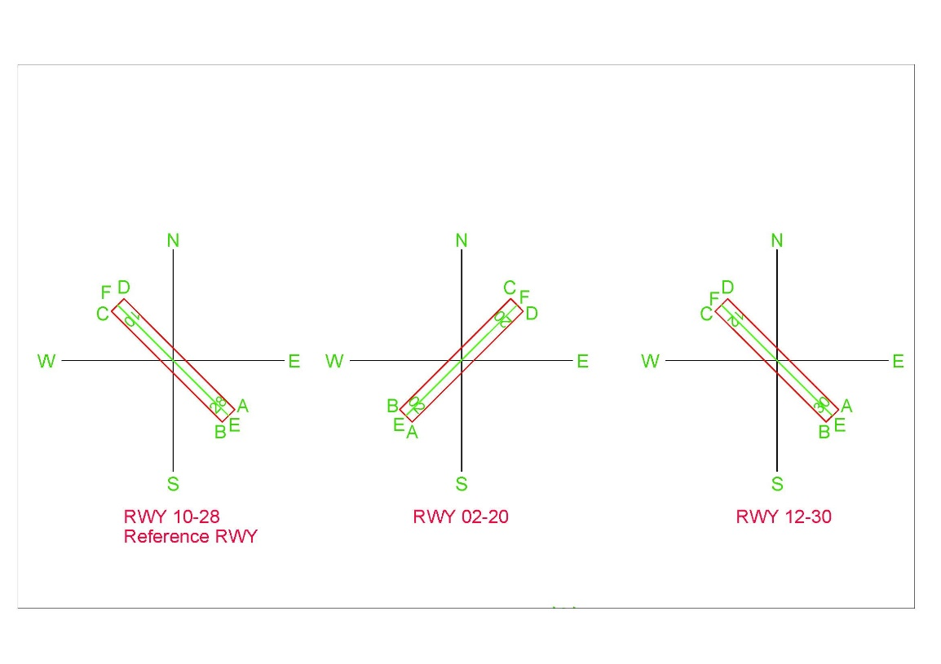

Figure . Runway corner nomenclature

## Output

### Report

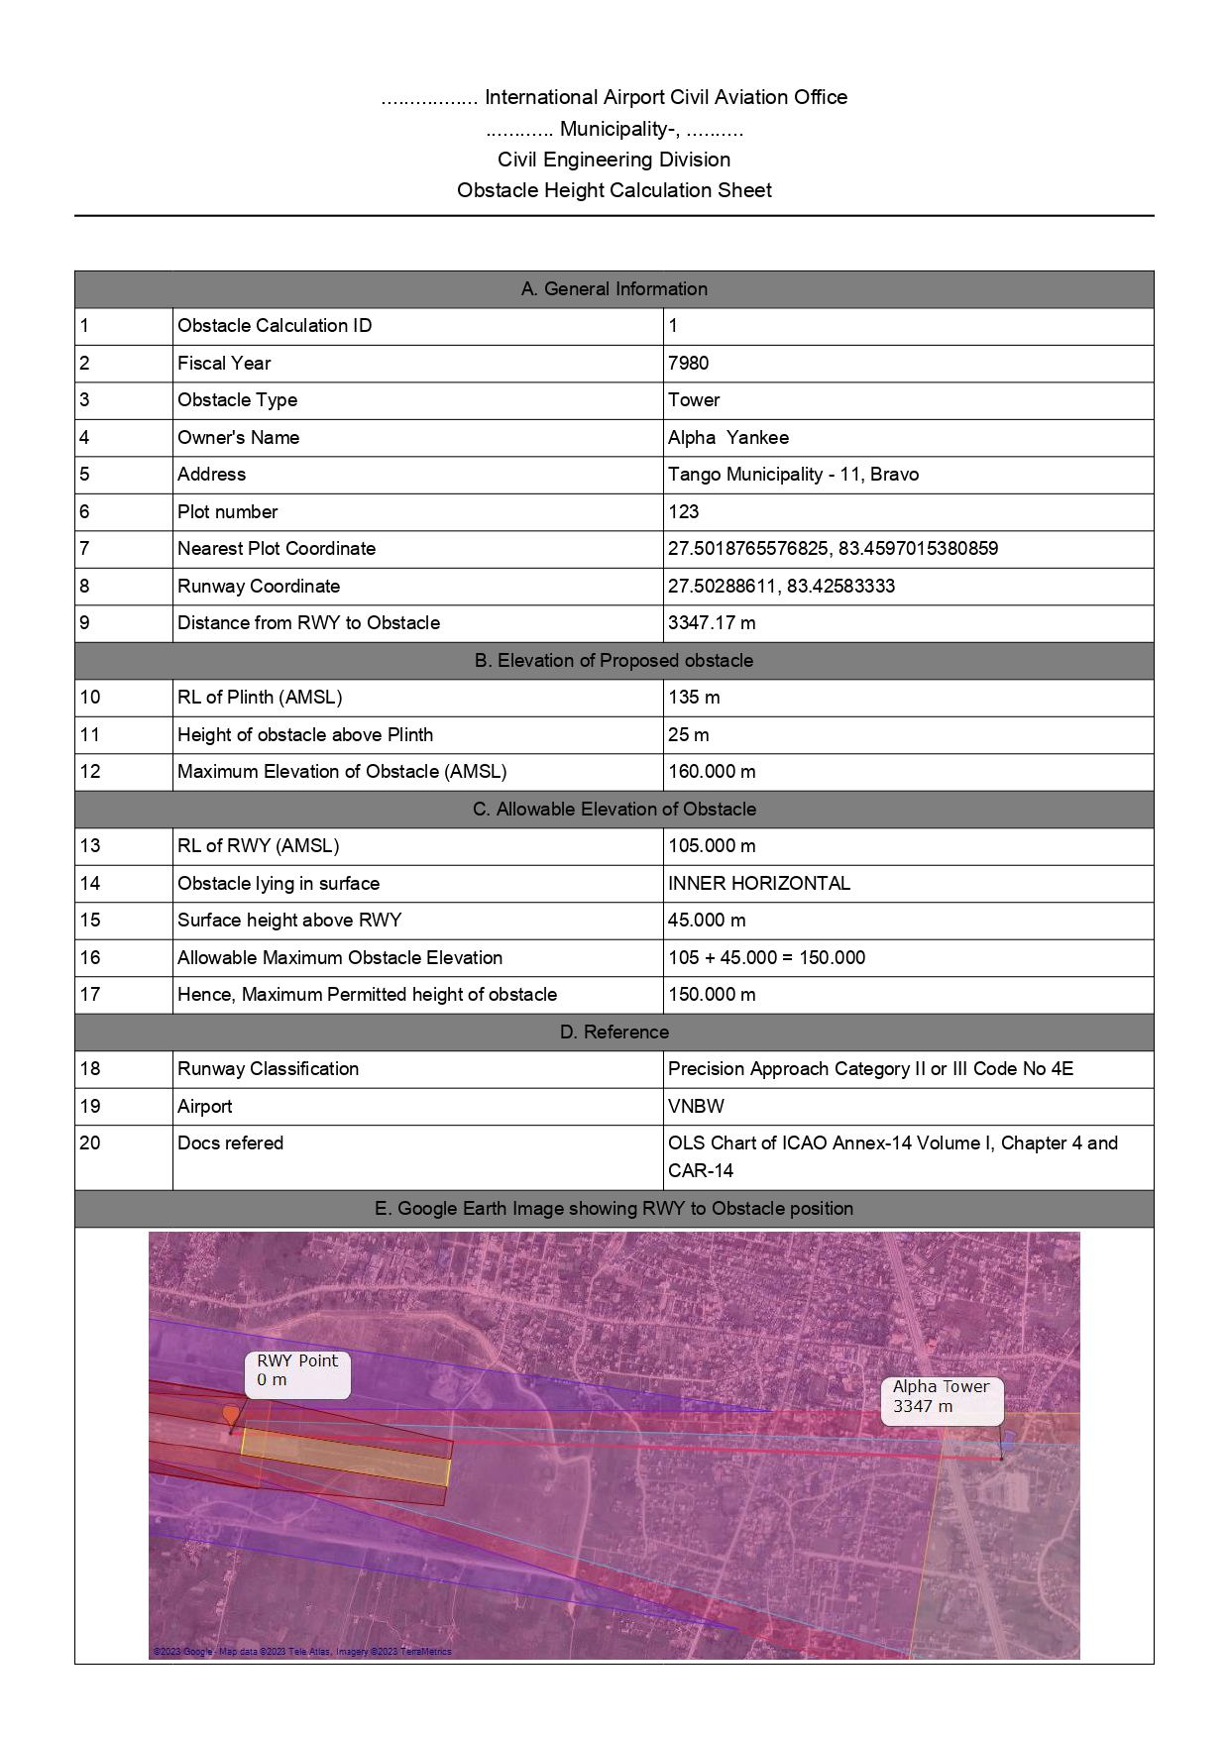

### Letter in Nepali

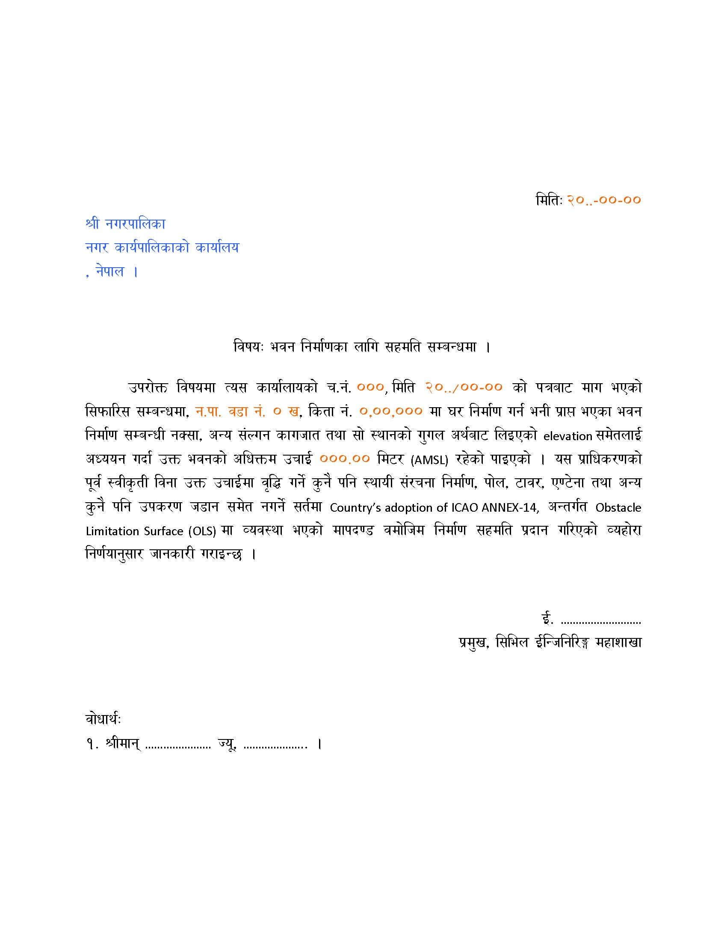

### Tippani in Nepali

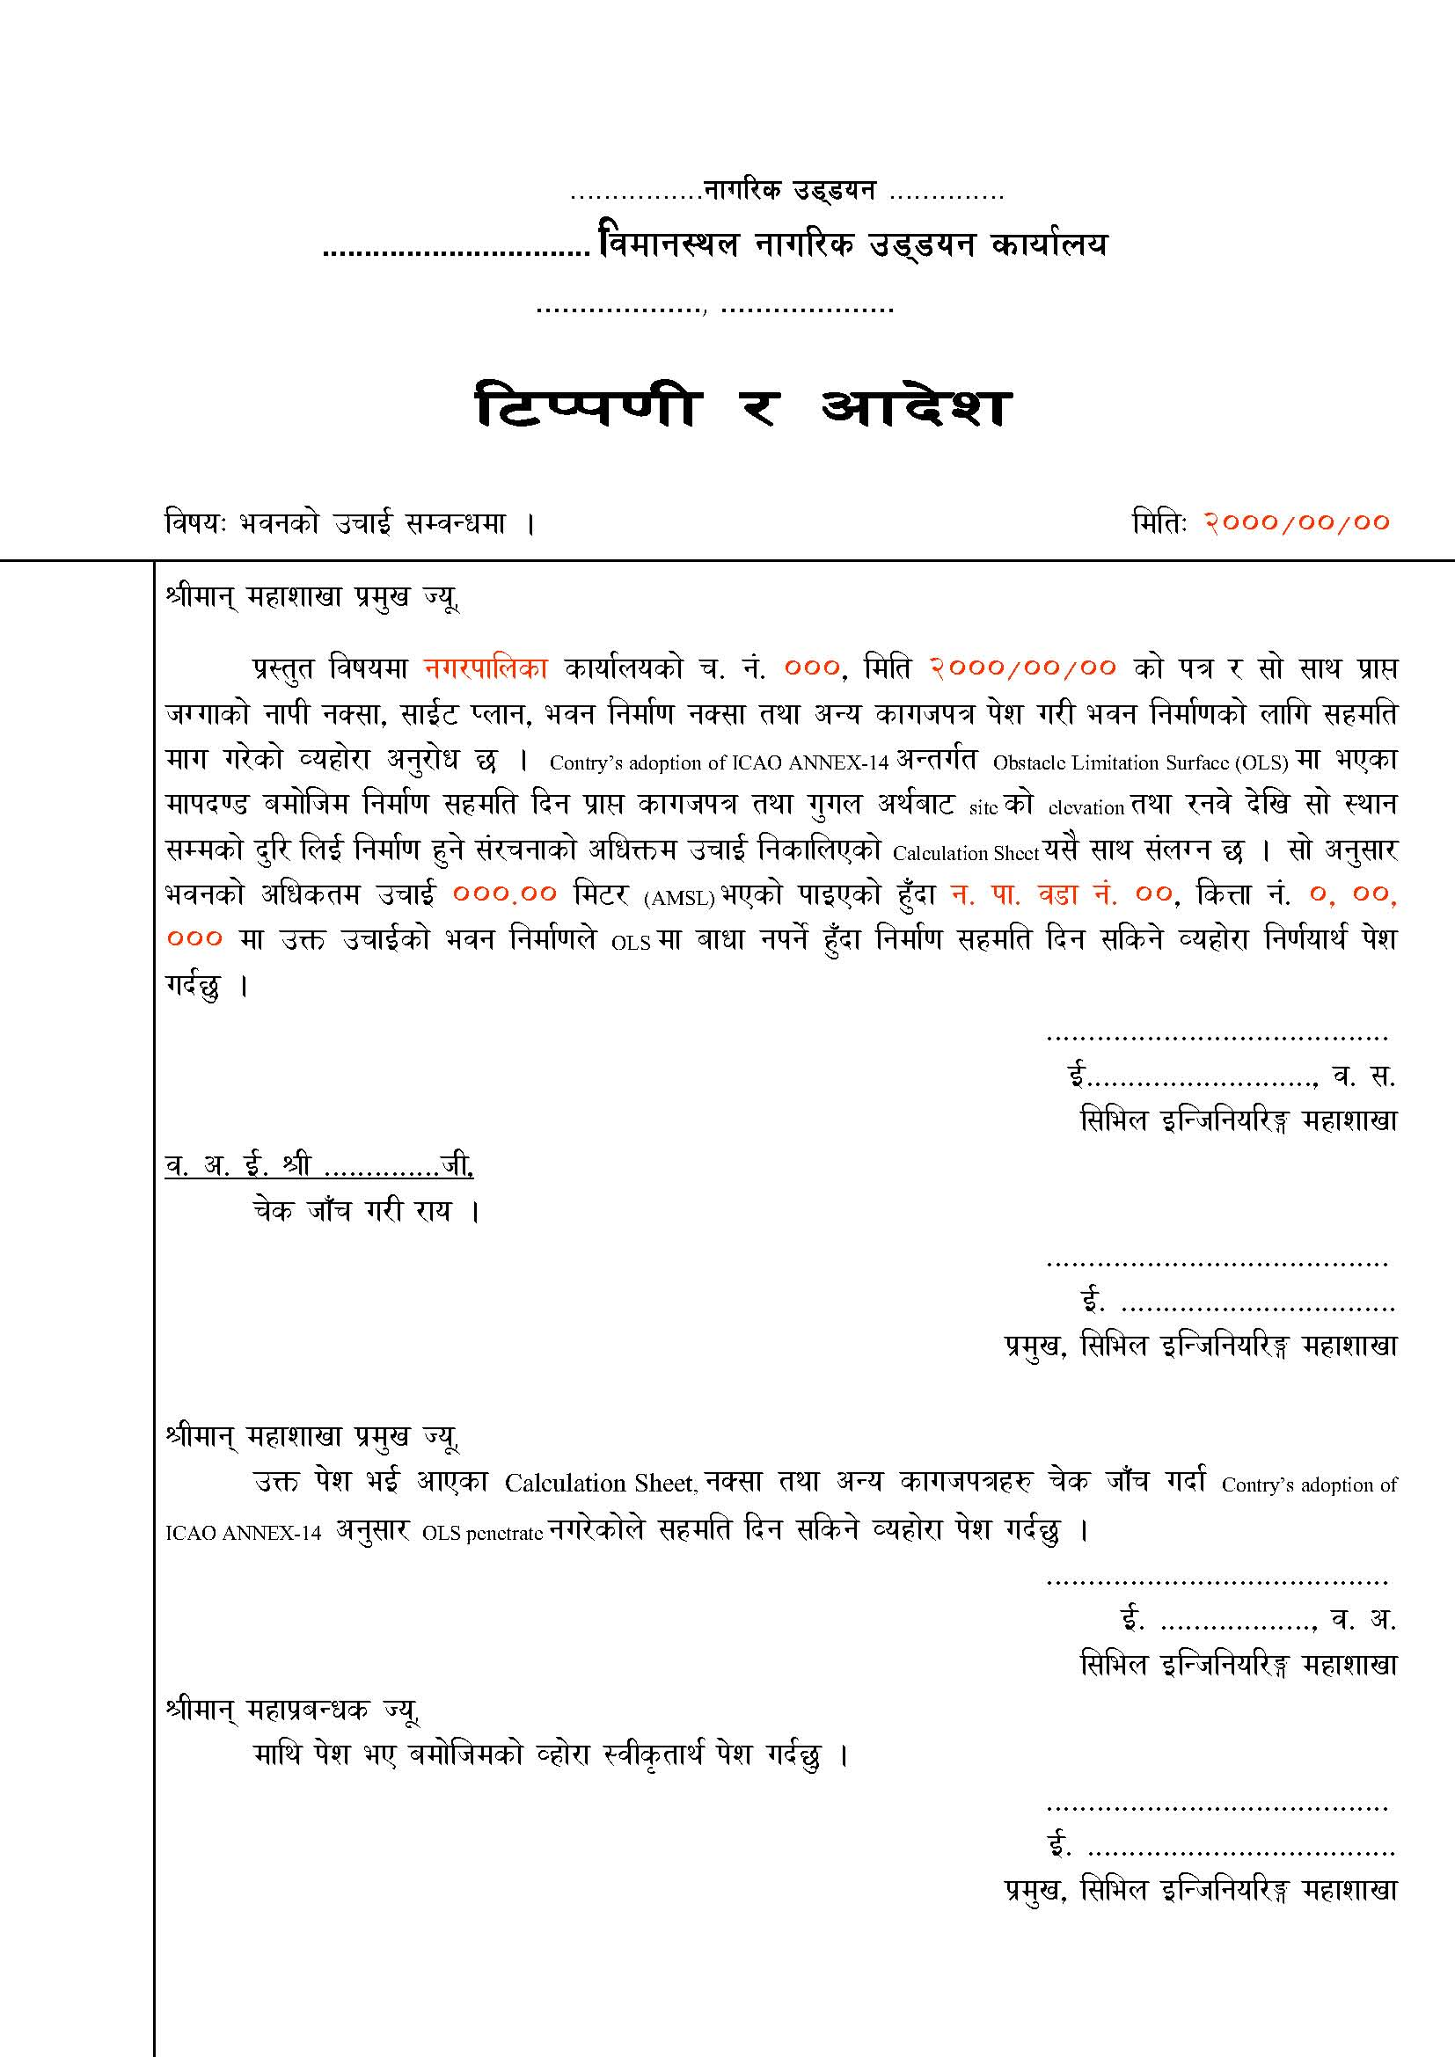

### Letter in English

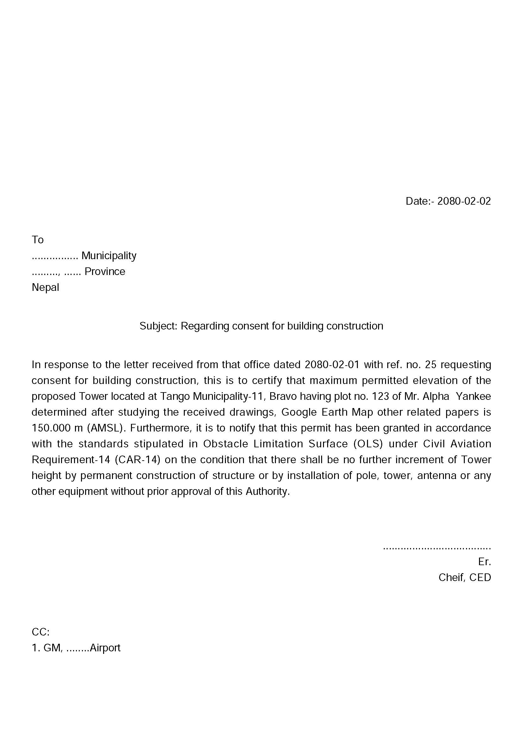

## Steps to calculate Obstacle Height with Auot-Process

The following steps shall be followed to calculate Obstacle height

1. Prepare input in all the text files as in Figure 12
2. Open the application

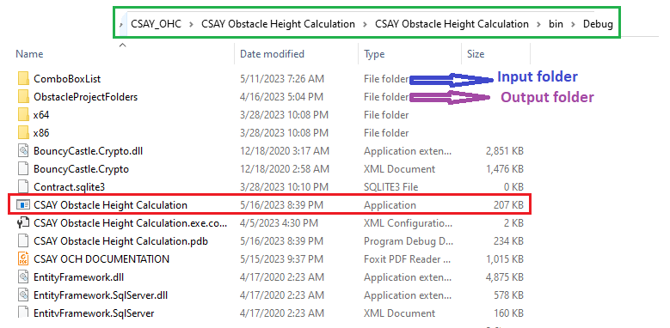

Figure 28. Software Executable file Location

1. The screen as in Figure 13 appears
2. Load RWY location data as in Figure 14
3. Navigate through different tabs and input all the fields labelled black in color as in Figure 15 to Figure 18.
4. Click “Auto process” as shown in Figure 24.
5. The output will be saved in “ObstacleProjectFolders” as shown in Figure 28.